CS2023 - In class Lab

Week 9 - Hash tables

Index: 200381U

**Note: You are required to answer the below questions and submit a PDF to the submission link provided under this week before the deadline (no extensions will be provided). You can either write / type your answers, but either way your answers should be readable.**

**Add the link to the GitHub repository**

# Lab instruction

Please download the lab materials.zip from the lab 9 section We will be implementing a Password look up system using hash tables. Please follow the instructions given by the instructor at the begining of the session to complete the lab.

Section 1 : Implementing basic hash table

Expected submission

1. Complete *hashfunc, insert, hash lookup*
2. Insert your name as user name and your index number as password. Print hash table and take screenshot.
3. Add 3 more user names and passwords. Print hash table and take screenshot.
4. Delete your user name. Print hash table and take screenshot.
5. What is issue when using a simple hash table like this and how can we change it, explain your answer.

Section 2 : Implementing hash table with chaining

Expected submission

1. Complete *hash lookup*

1

1. Insert your name as user name and your index number as password(do it two times). Print hash table and take screenshot.
2. Add 3 more user names and passwords. Print hash table and take screenshot.

**Answers:**

**Section 1**

1.

2.

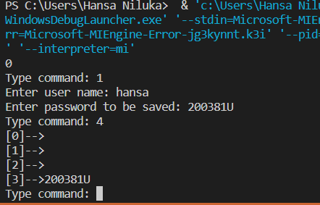

3.

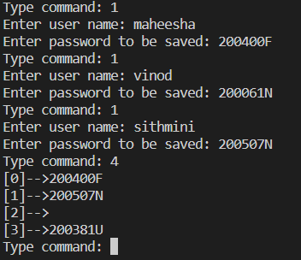

4.

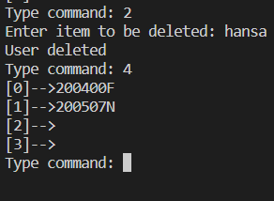

5.

When there’s a collision between keys new value will overwrite the old value (which is linked to the older key). To avoid this error, we can use proper collision avoiding method like chaining.

**Section 2**

1.

2.

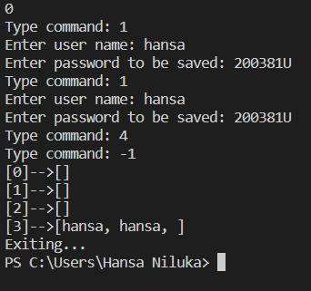

3.

